9. Complaints Policy and Procedure
General statement
THE RH YOUTH ORGANISATION aims to provide its members, organisations and individuals with the best possible service. We positively welcome suggestions you may have for how we can improve our service.

Usually, a word with the person at the point of service delivery will suffice should a problem arise. However, we recognise that from time to time there may be occasions when users of our services feel that the quality or level of service provided fall short of what they could reasonably expect. We also want to know about these occasions so that we can make good of the problem and plan to avoid its repetition. If you have a complaint, we would like you to tell us about it.

This is what you should do:
- If you have a complaint to make, it should be made to a Team Member or Team Leader who will try to resolve the issue informally.

- If the issue is serious, or you are not satisfied after raising it with the Team Leader you should make a formal complaint.

- If the issue is regarding child welfare or a safeguarding concern, the Chief Executive should be notified immediately, who along with the Child Protection Officer will determine whether Social Services or Police should be contacted.

- Your complaint should be made in writing, marked “Private & Confidential", and sent to the Chief Executive who will acknowledge it in writing (normally within 7 days of receipt). Remember to keep a copy of your letter. If you need an interpreter or advocate to help you make your complaint, THE RH YOUTH ORGANISATION can arrange this for you.

- The Chief Executive shall - in consultation with the Chair of the Trustee Board - investigate the complaint. (See separate check list).

- The Chief Executive shall communicate the results of the investigation to you within a reasonable time - normally 21 days.

- You have the right - if dissatisfied with the results of the inquiry - to put your case in writing or personally to a panel comprising at least three members from the THE RH YOUTH ORGANISATION Trustee Board.

- If attending personally, you have the right to be accompanied by a friend or advocate to help put your case. (The panel also has the right to have an advisor present).

- The decision of the panel will be final.

- Where appropriate, THE RH YOUTH ORGANISATION will make a written apology to the complainant, and agree any further action necessary to make good the cause of the complaint.

- All formal complaints and the response made to them will be recorded and filed in a secure place.

- The Trustee Board shall be informed by the Chief Executive at the first available meeting of the number and nature of any formal complaints and their outcome, and consideration will be given to the implications these have for the planning and management of future services annually, as part of THE RH YOUTH ORGANISATION’s self-evaluation.

THE RH YOUTH ORGANISATION’s complaints procedure will be publicised to organisations and individuals who use its services.

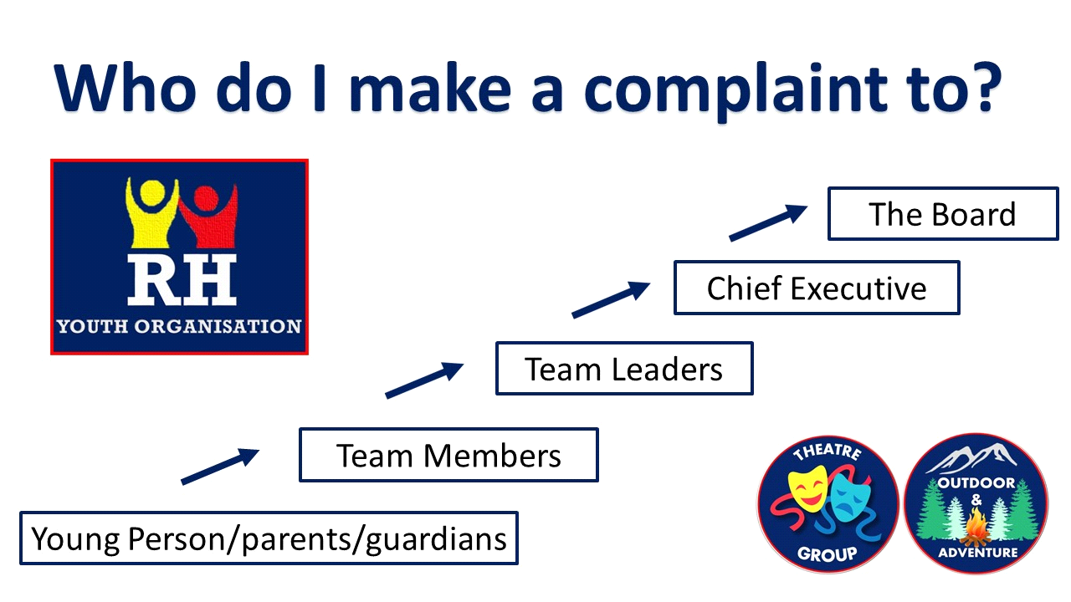

This policy is to be read in conjunction with the following documents –
Appendix 1 – Formal Complaint Form
Appendix 2 – Chief Executive Complaint Checklist

END OF 9. COMPLAINTS POLICY

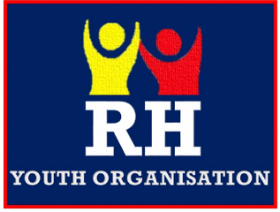
APPENDIX 1 –

The RH Youth Organisation
Formal Complaint Form
It is THE RH YOUTH ORGANISATIONS policy to investigate all complaints and take appropriate action. If you wish, please use this form to document your complaint, and submit it to The Chief Executive or the Organisation’s Board.
The person(s) involved in this complaint are:

Note all relevant dates, places, events, etc. pertaining to the complaint:
(Use second sheet if necessary.)
Page 1

Page 2
It may become necessary to disclose your identity and/or complaint, as well as to conduct a formal investigation. Should such a disclosure become necessary, it will be only to the person(s) with a need to know your identity or the details and nature of the complaint.

I acknowledge that I have read this document and understand my obligation to provide information as needed and to cooperate fully and completely with any investigation of this complaint. Should it become necessary, I authorize THE RH YOUTH ORGANISATION to disclose my identity and/or details of this complaint.

Your Name

Date
Signature

Chief Executive

Date
Signature

APPENDIX 2 –
Chief Executive Complaints Checklist

Use this checklist when investigating a complaint as part of the organisations
Complaints Policy and Procedure.

Have you conveyed verbally to the complainant the investigation procedure and timescale? | YES/NO
Have you conducted an interview to establish background to and detail of the complaint? | YES/NO
Have you written a statement about the complaint which you have dated and signed? | YES/NO
Has the complainant countersigned as correct the statement you have taken? | YES/NO
Have you given a copy of the complaint to those associated with its contents? | YES/NO
Have you asked, in writing, for a statement from those associated with the complaint within an agreed period of time? | YES/NO
Have you received the statements within the agreed time period? | YES/NO
Have you advised those being interviewed that they can have a representative or friend with them? | YES/NO
Have you interviewed all those associated with the complaint? | YES/NO
Have you written up, signed, and dated your notes from each of these interviews? | YES/NO
Have you reviewed all the evidence placed before you? | YES/NO
Have you assessed whether or not you feel there are grounds for complaint? | YES/NO
If so, have you considered all the options for action that could/should be taken as a result? | YES/NO
Are you clear in your own mind what will be the content of the discussion with the Chair about this investigation and its findings? | YES/NO
Have you discussed fully with the Chair the findings of your investigation and your recommendations for action? | YES/NO
Have you put these formally in writing to the Chair, together with the statements and notes taken during the course of the investigation? | YES/NO

