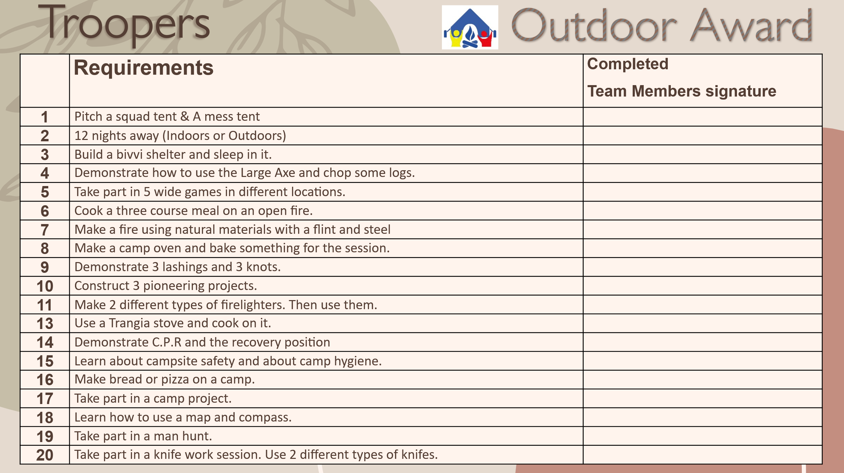

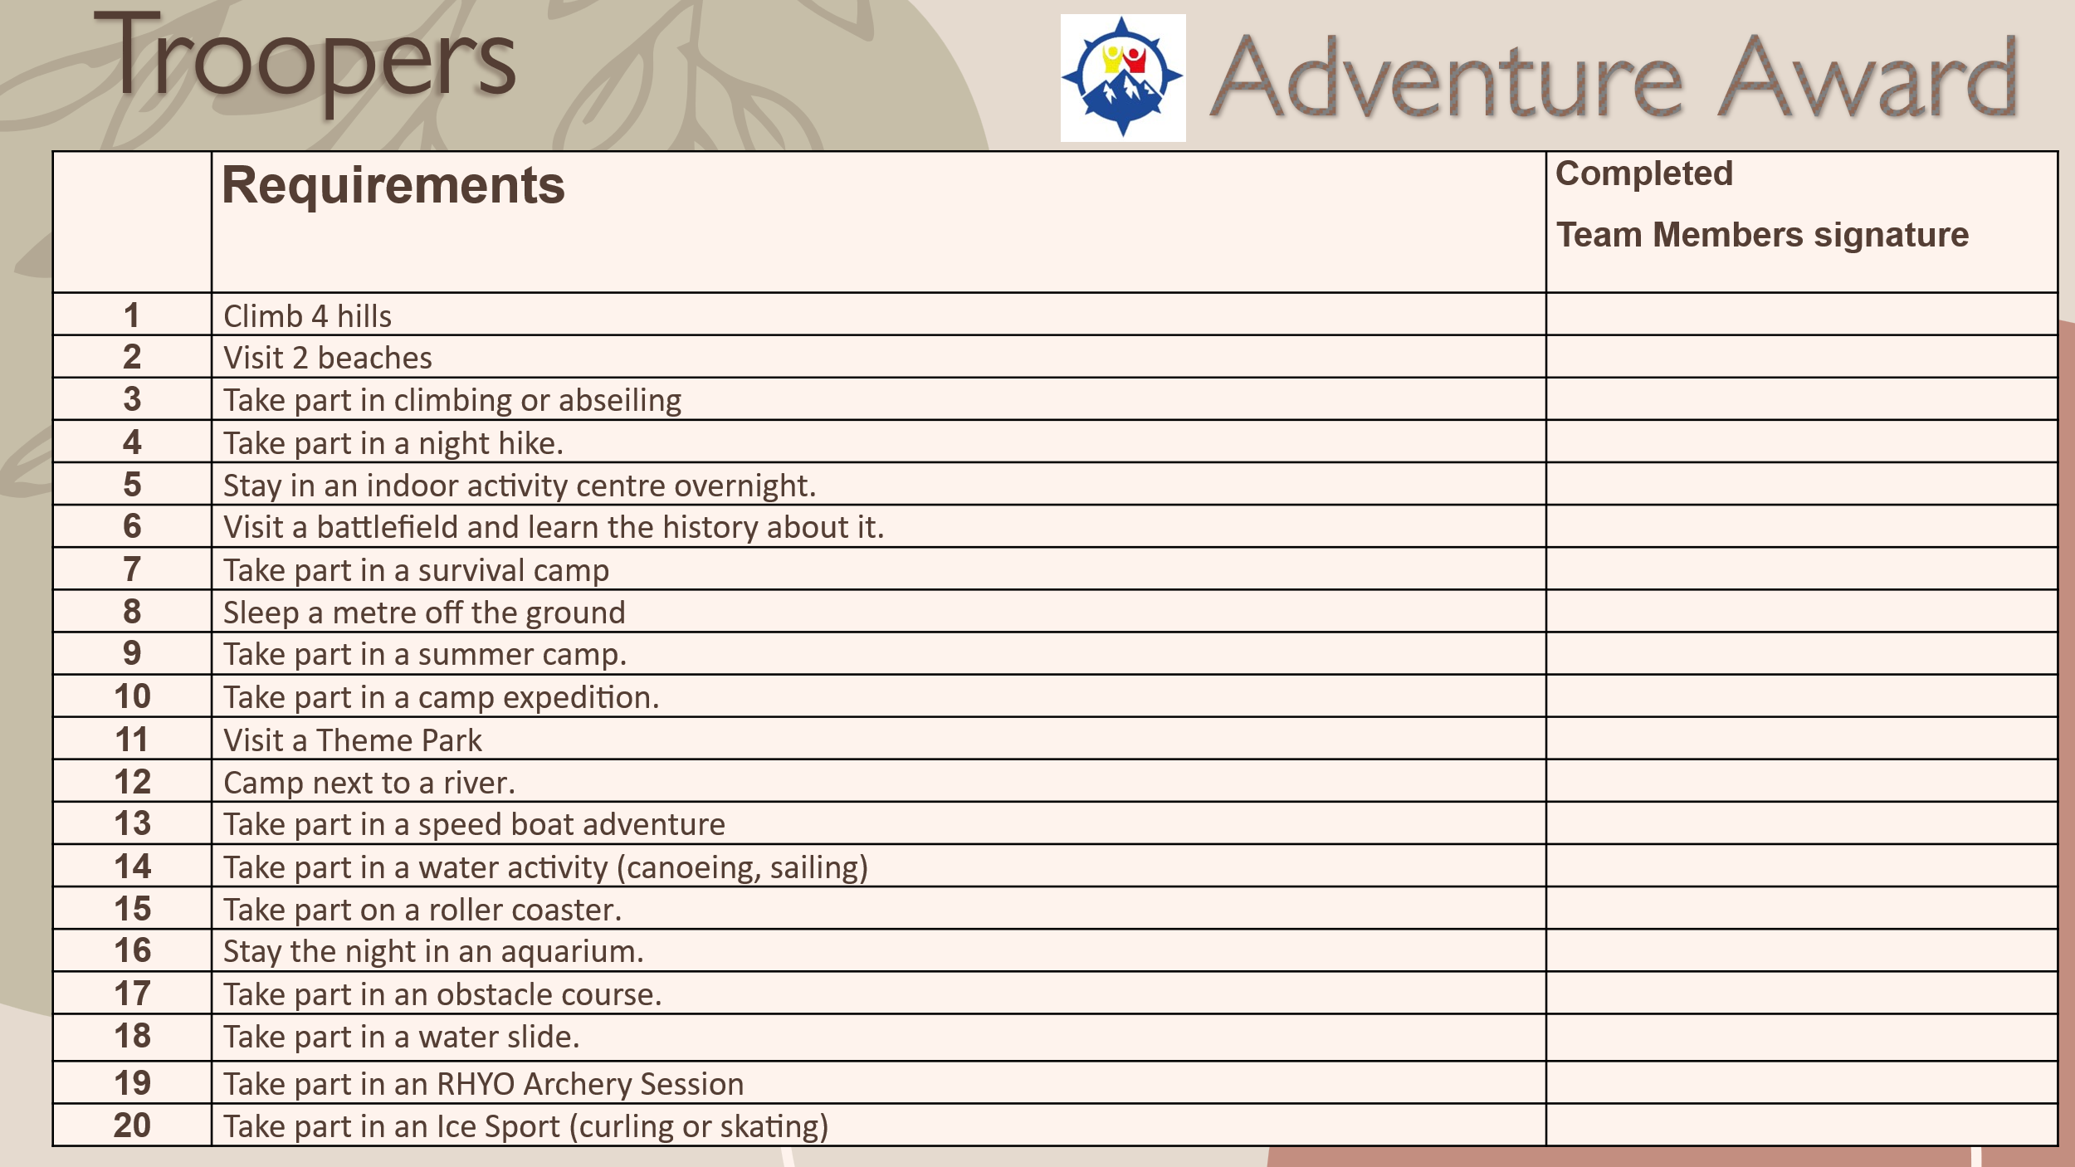

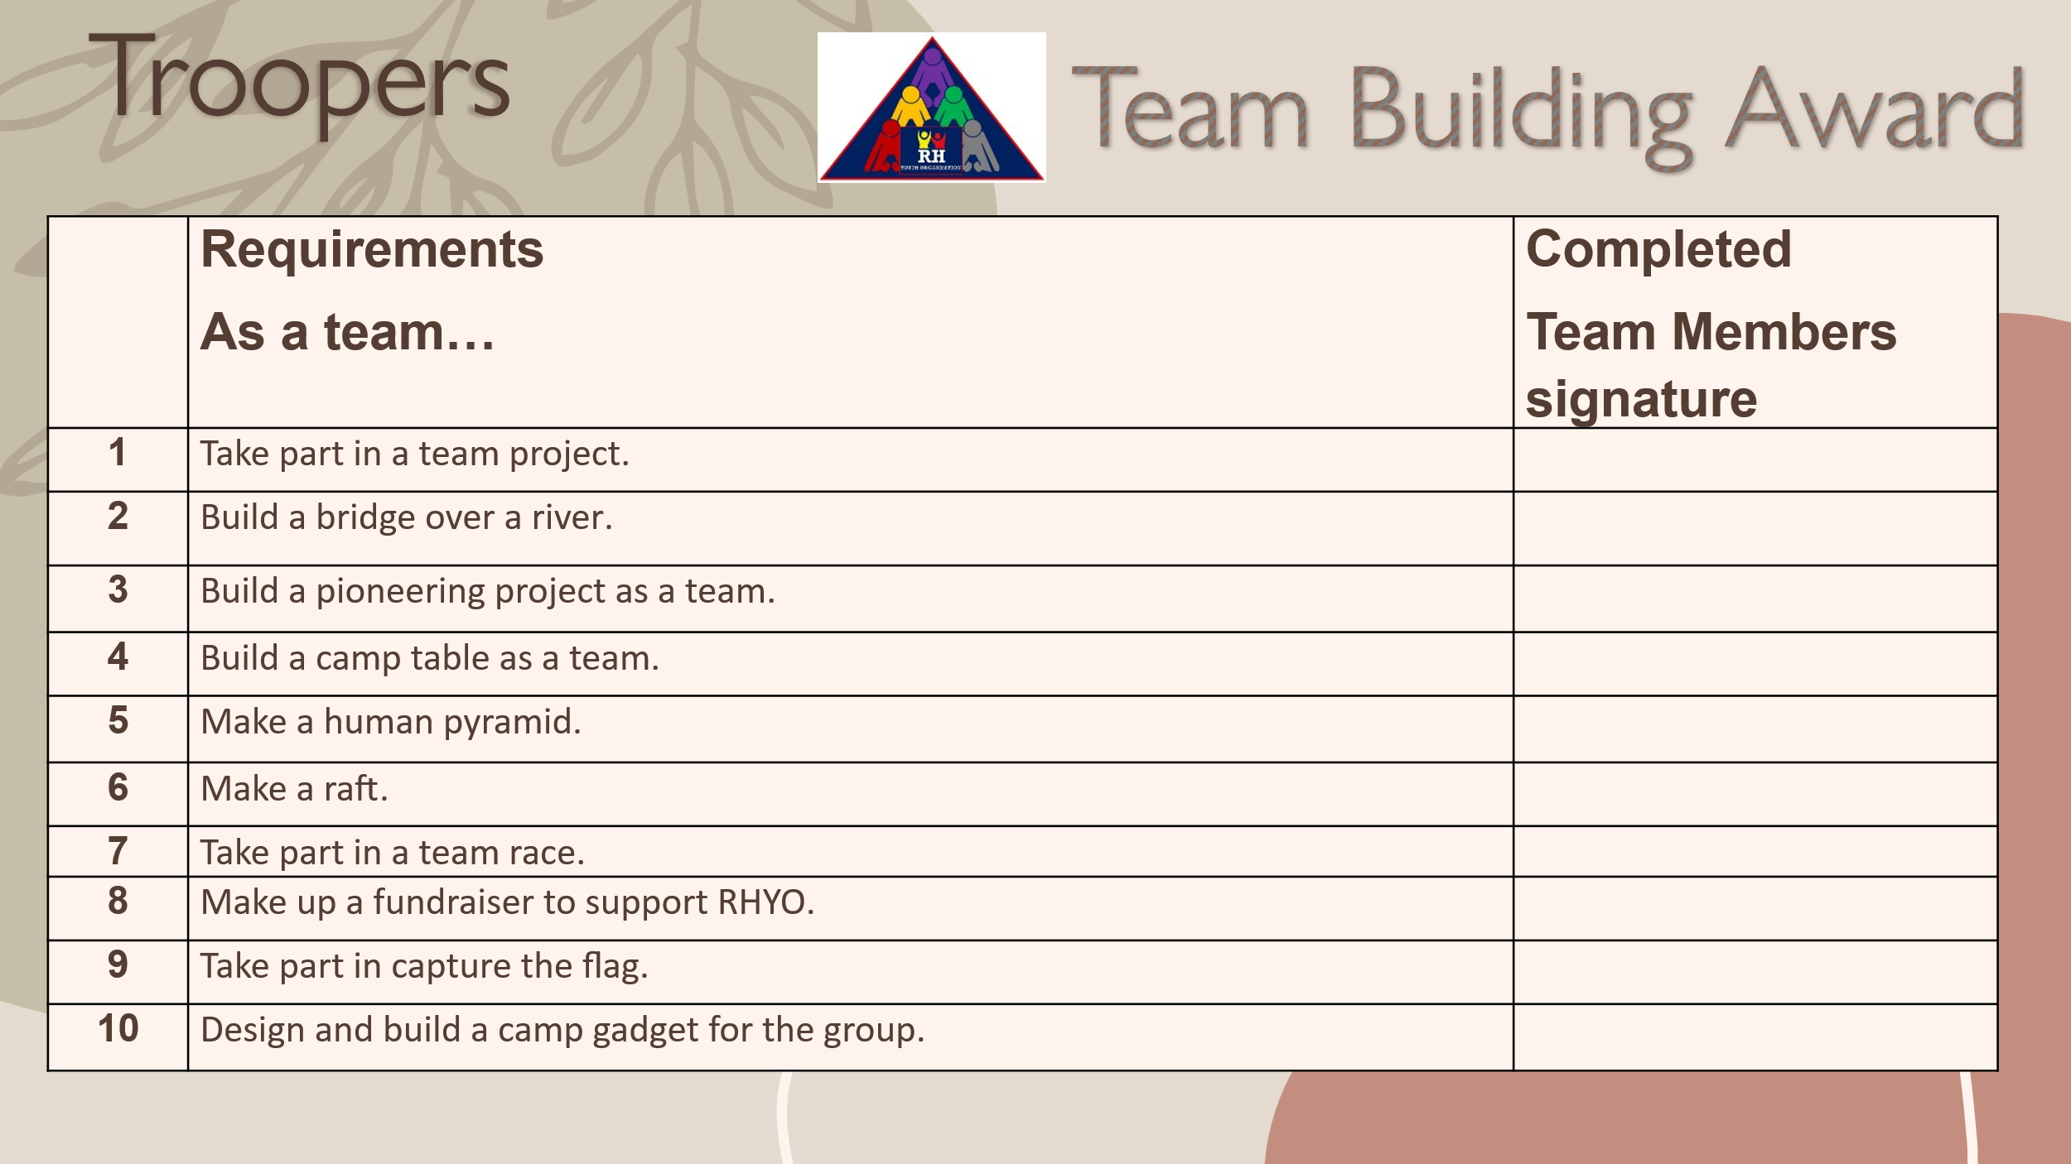

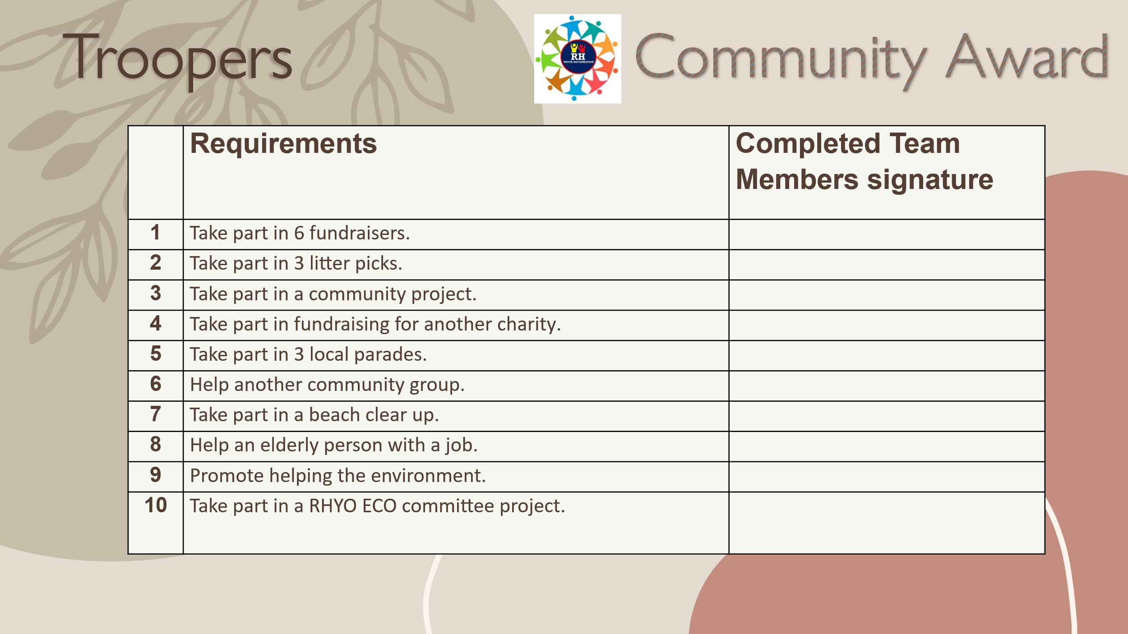


Troopers (11-13 years old)
Requirements for the
Outdoor and Adventure Awards

Below are the session awards. Some requirements should be completed during sessions, while those highlighted in yellow can be done at home with adult supervision. For at-home work, participants must provide evidence (e.g., photos or signatures) to a team member.
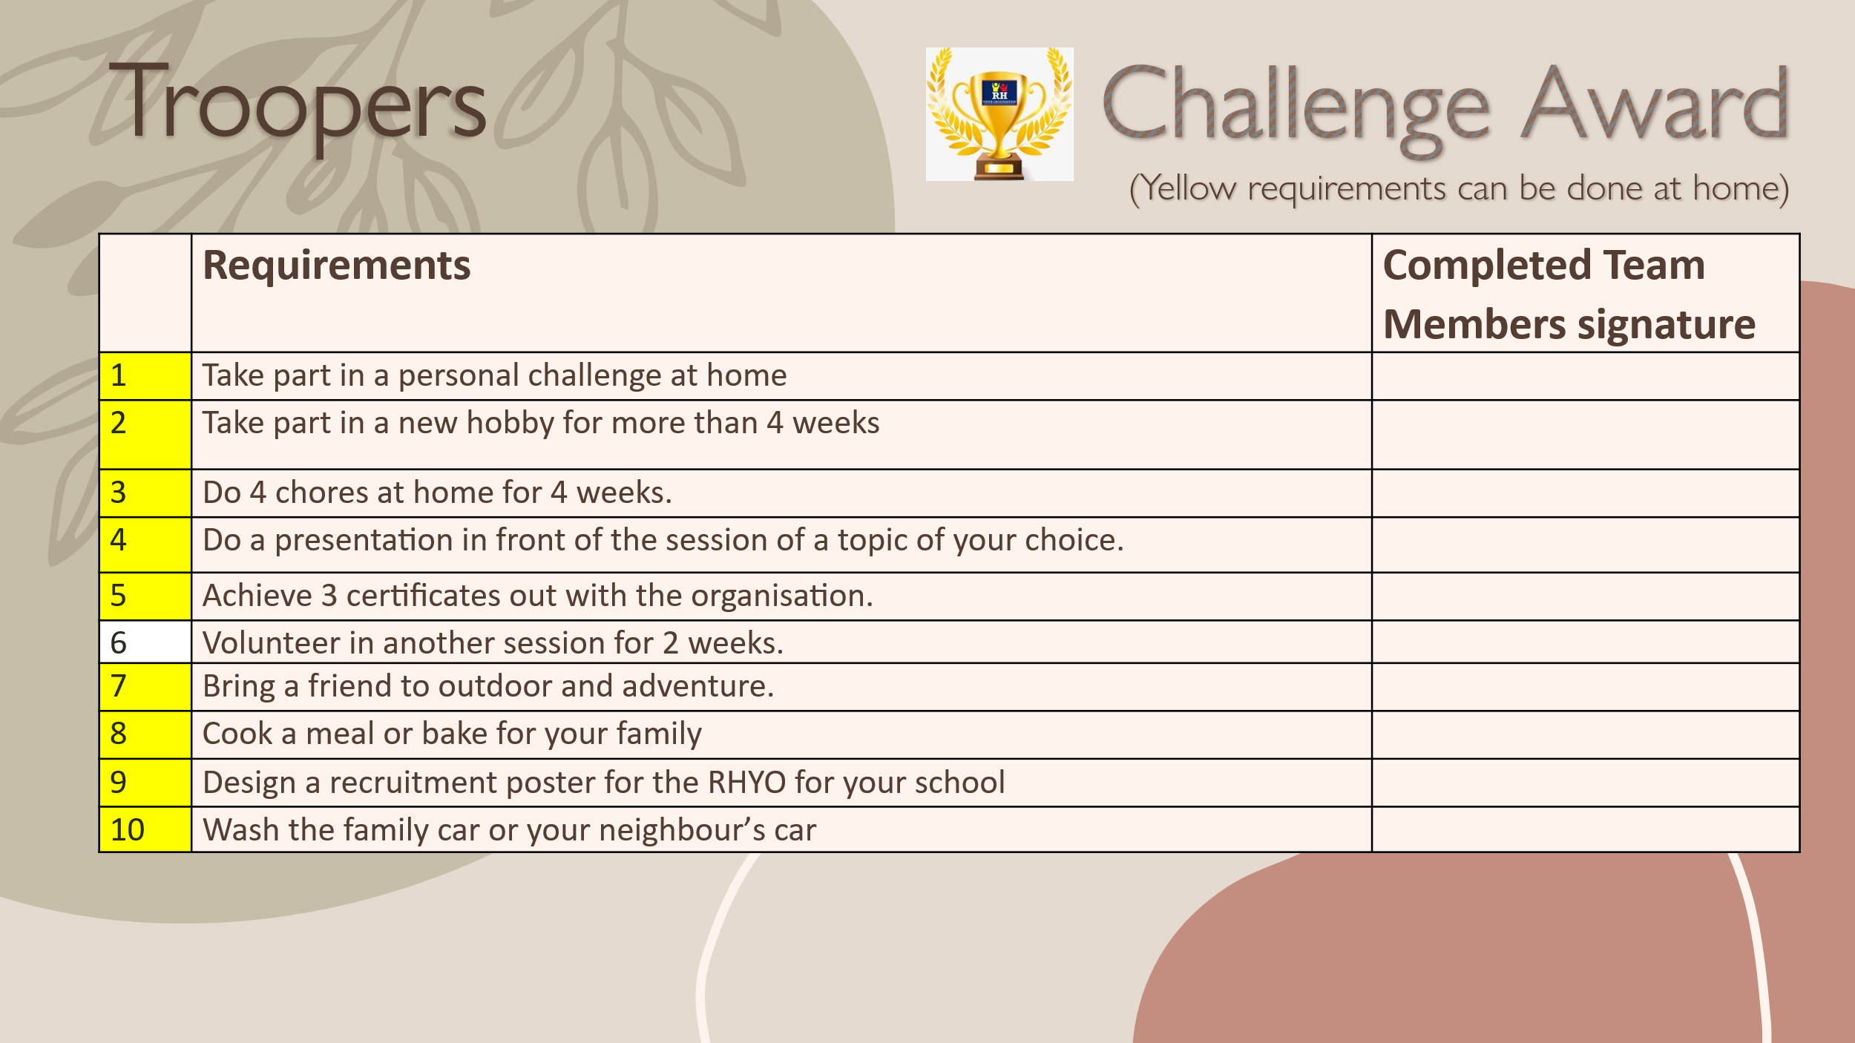



TROOPERS
Award
Requirements booklet

Version 2026

