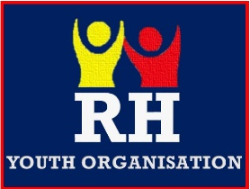
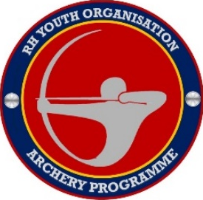
Archery party package- Food order form
 | Name of person | Sandwich option-  (Ham, cheese, Jam) | Fruit option-  (Apple, banana, orange) | Allergies we need to know
1
2
3
4
5
6
7
8
9
10
11
12
13
14
Lunch boxes contain- sandwich, crisps, fruit & biscuit. A jug of juice will be provided on the table.

Please fill in the form and send to rhyouthorg@hotmail.com and return a week before your event.

